Keratin

-Main structural component of hair, horns, hooves, feathers, claws, etc.

-Made by Keratinocytes

http://www.biology-questions-and-answers.com/protein-synthesis.html
http://study.com/academy/lesson/organelles-involved-in-protein-synthesis.html#lesson
http://www.infoplease.com/cig/biology/protein-synthesis.html

DNA is copied to RNA (transcription) so it can move through the nuclear membrane
RNA moves out of nucleus to ribosomes in the rough ER and cytoplasm
Genes provide the blueprint for RNA, which directs protein synthesis

Transcription:
- The process is initiated in the cell’s nucleus
- RNA polymerase enzyme “unzips” the DNA so it’s two different strands, binds to promoter segments that indicate the start of a single DNA strand to be copied, and matches the DNA with complementary RNA nucleotide to create RNA that is patterned after the DNA
- RNA polymerase reaches a termination signal, which is a set of nucleotides that indicate the end of the gene that needs to be copied and detaches the DNA from the new RNA
- DNA goes back to its original double-helix structure, RNA moves out of nucleus
3 types of RNA:
- mRNA (messenger RNA, transcribed from DNA and carries genetic info from DNA to amino acids)
- tRNA (transfer RNA) interprets the three letter codons of the nucleic acids to the one letter amino acid word
- rRNA (Ribosomal RNA, make up ribosomes along with proteins, most common type)
Translation:
- mRNA moves to ribosomes and is “read” by tRNA, which analyzes the sections of 3 adjoining nucleotide sequences (codons) on the mRNA and brings the right amino acid into the polypeptide chain that is being assembled
- Amino acids combine in the correct sequence to form a protein that the DNA coded for
Assembly of the polypeptide:
- Begins when a ribosome attaches to a start codon on the mRNA.
- tRNA carries the amino acid to the ribosomes (made of rRNA and protein and have three bonding sites to promote synthesis). First site orients mRNA so the codons are accessible to the tRNA, which occupy the remaining two sites as they deposit their amino acids and then release from the mRNA to search for more amino acids.
- Translation continues until the ribosome recognizes a codon that signals the end of the amino acid sequence.
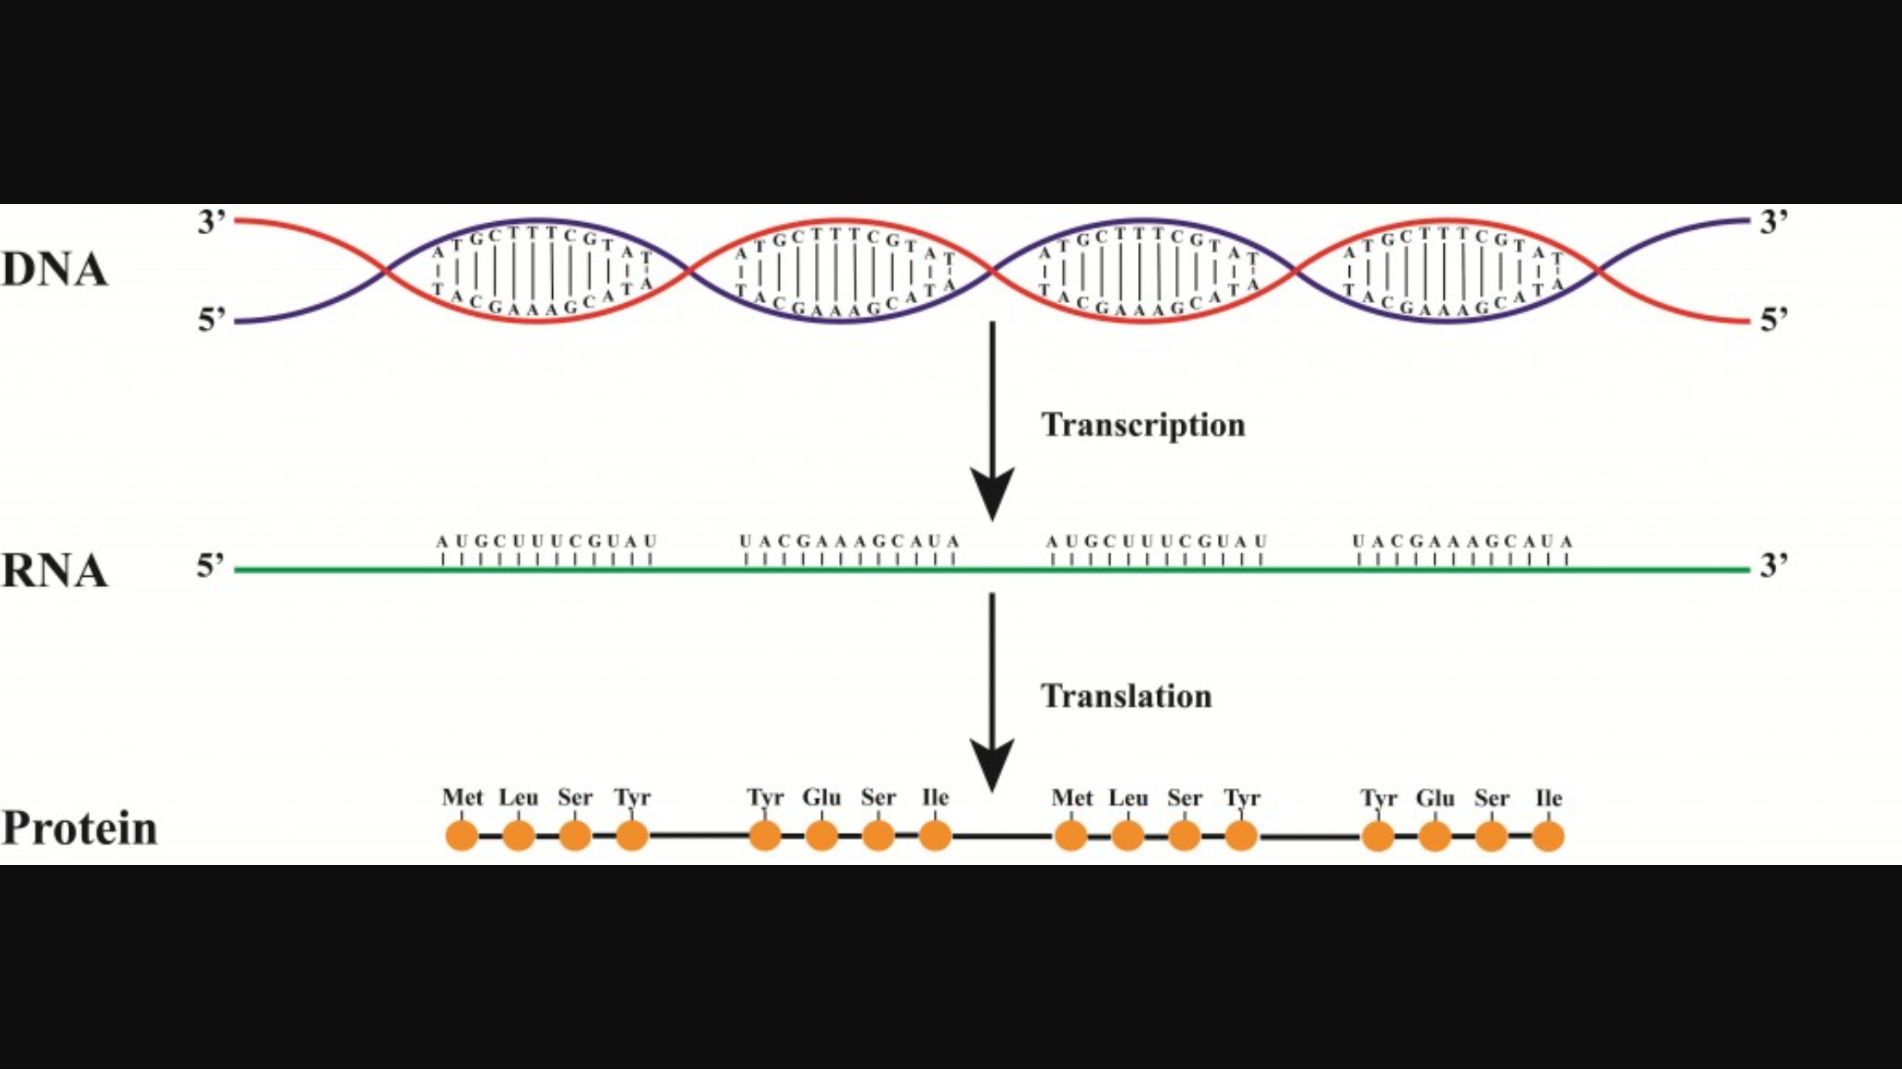
- The polypeptide, when completed, is in its primary structure. It’s released from the ribosome to begin contortions to configure into the final form to begin its function.

